Unit 03 Problem Set Submission Form

# Overview

|  |  |
| --- | --- |
| Your Name | Rayanna Harduarsingh |
| Your SU Email | rharduar@syr.edu |

# Instructions

Put your name and SU email at the top. Answer these questions all from the lab. When asked to include screenshots, please follow the screen shot guidelines from the first lab.

Remember as you complete the problem sets it is not only about getting it right / correct. We will discuss the answers in class so it’s important to articulate anything you would like to contribute to the discussion in your answer:

* If you feel the question is vague, include any assumptions you've made.
* If you feel the answer requires interpretation or justification provide it.
* If you do not know the answer to the question, articulate what you tried and how you are stuck.

This how you receive credit for answering questions which might not be correct.

# Questions

Answer these questions using the problem set submission template. You will need to consult the logical model in the overview section for details. For any screenshots provided, please follow the guidelines for submitting a screenshot.

1. A screenshot of a cell phone

   Description automatically generatedAdd the **contractors** table as defined in the overview section to your SQL script at the bottom of your --UP Metadata section. Include columns, indexes (pk/unique) in the create table statement. Provide a screenshot of the SQL code.
2. Add the reverse command to the --DOWN section of your SQL script, dropping the table. Provide a screenshot of the code.A screenshot of a cell phone

   Description automatically generated
3. Alter the **contractors** table adding a foreign key over the **contractor_state** column, **fk_contractors_contractor_state.** Add it to the --UP Metadata portion of the script. Provide a screenshot of the SQL code.A screenshot of a cell phone

   Description automatically generated
4. Add the reverse command to the DOWN section of your SQL script, dropping the foreign key. It should be a soft delete as with the other foreign key in the walkthrough. Provide a screenshot of the code.A screenshot of a cell phone

   Description automatically generated
5. At the bottom of the --UP Data section, insert the following contractor data.  
   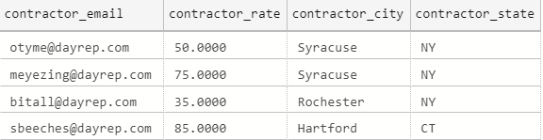 Add a select statement to the –Verify section. Provide evidence your script works to this point by including a screenshot of the table outputs.A screenshot of a cell phone

   Description automatically generated
6. Create the **jobs table** with pk and check constraints. Add it to the appropriate section of the script and provide a screenshot of the SQL code.A screenshot of a social media post

   Description automatically generated
7. Add the drop table statement for the **jobs table**, add it to the appropriate section of the script and provide a screenshot of the SQL code.

1. Add the two foreign key constraints to the **jobs table.** Add it to the appropriate section of the script and provide a screenshot of the SQL code.A screenshot of a social media post

   Description automatically generated
2. Add code to softly remove the foreign key constraints from the **jobs** table. (should be two separate checks for drops). Add it to the appropriate section of the script and provide a screenshot of the SQL code.A screenshot of a cell phone

   Description automatically generated
3. A screenshot of a cell phone

   Description automatically generatedWrite SQL code to insert the following jobs to the **jobs table**.  
   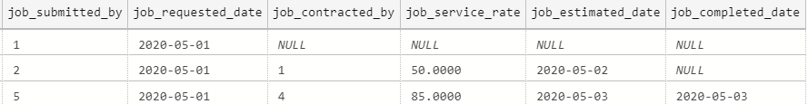  
   Provide evidence the entire script works by including a screenshot off all 4 tables with data in them.

# Reflection

Use this section to reflect on your learning. To achieve the highest grade on the assignment you must be as descriptive and personal as possible with your reflection.

1. What are the key things you learned through the process of completing this assignment?  
   I learned how to create a database using the up/down script. It helps us track our changes and progress. I also learned how to use Azure Data Studio and connect to a database and launch a query from there. This problem set was also great practice for having to manually write out code when creating tables, inserting data, and altering tables to add constraints.
2. What were the challenges or roadblocks (if any) you encountered on the way to completing it?  
   Some of the challenges were more syntax errors. It made me realize I have to be careful when typing because even the littlelest mistake, such as a missing comma, can throw you off and cause errors. Also, it was a little difficult writing out the check constraints and making sure the expression was done correctly.
3. Were you prepared for this assignment? What can you do to be better prepared?  
   Yes I was prepared for the assignment having read and watched the lessons from Unit 3 as well as reading the lab.
4. Now that you have completed the assignment rate your comfort level with this week’s material. This should be an honest assessment: (choose one)  
     
   **4 ==> I understand this material and can explain it to others.**  
   3 ==> I understand this material.  
   2 ==> I somewhat understand the material but sometimes need guidance from others.  
   1 ==> I understand very little of this material and need extra help.